EXPREMENT 11: IMPLEMENTATION OF SLIDING WINDOW PROTOCOL USING C

PROGRAM:
#include<stdio.h>
int main(void) {
int total, window, base = 0, i, end;

printf("Enter total number of frames:
");
if (scanf("%d", &total) != 1) return 1;

printf("Enter window size: ");
if (scanf("%d", &window) != 1) return 1;

if (total <= 0 || window <= 0) { printf("Enter positive values only.\n"); return 1;
}

printf("\nSliding Window Protocol Simulation\n");

while (base < total) { end = base + window; if (end > total)
end = total;

printf("\nSender window: frames %d to %d\n", base, end - 1);

for ( i = base; i < end; i++)
printf(“sender : send frame %d\n”, i);

for (i = base; i < end; i++) {
printf("Receiver: Frame %d received\n", i); printf("Receiver: ACK %d sent\n", i);
}

base = end;
printf("Sender: Window moved forward\n");
}

printf("\nAll frames sent and acknowledged.\n"); return 0;
}

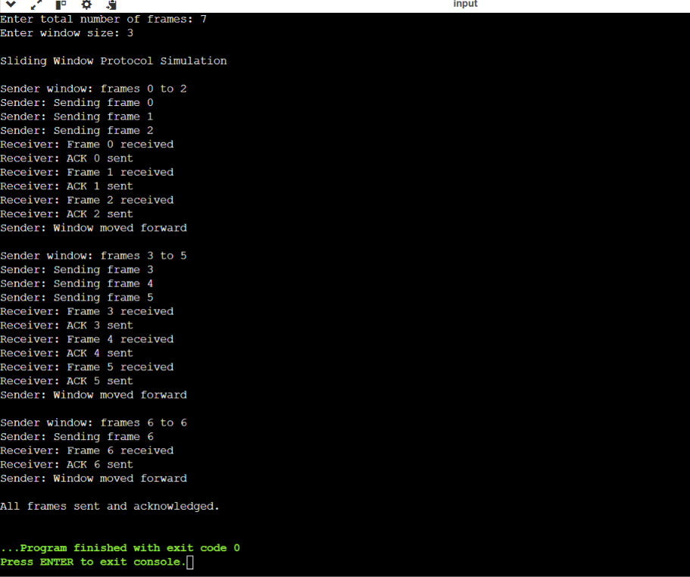
OUTPUT:

